**Principles of Data-Base Management System**

Prashanth.S

19MID0020

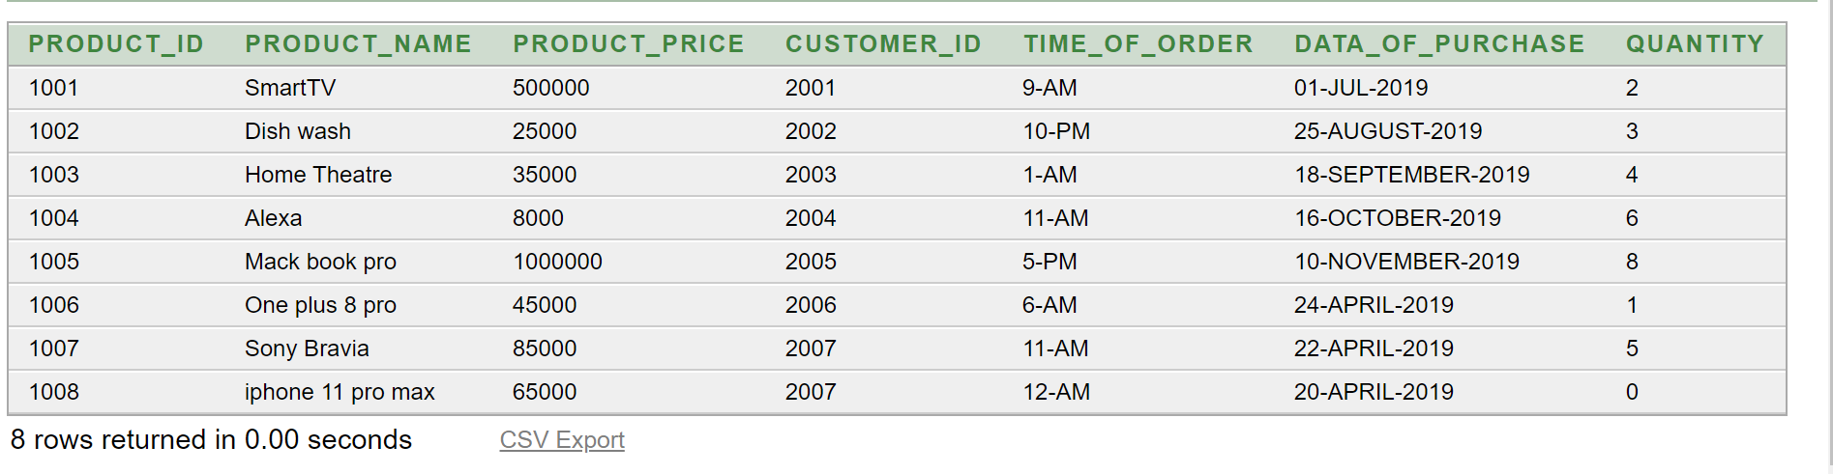

1. Write a PL/SQL block to retrieve the product name, product price of a particular product identified by the product_id from the amazon table by reading product_id value during runtime.

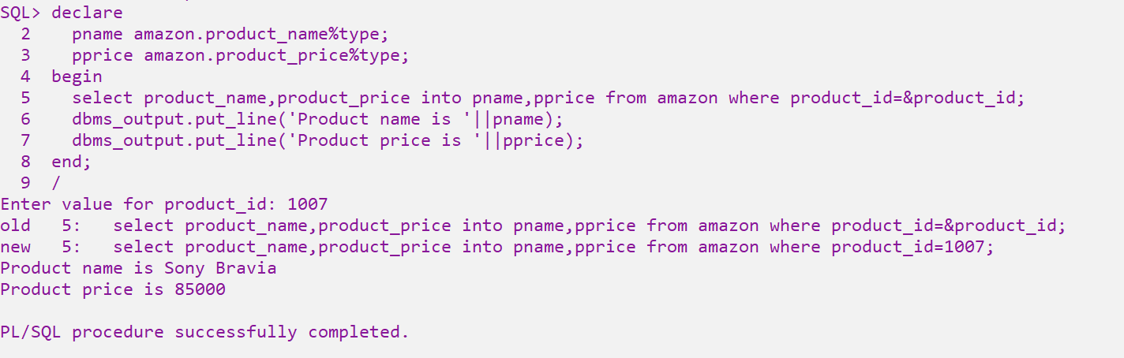

1. Write a PL/SQL block to change the quantity to 5 for product whose product_id is 1008 interactively by reading the product_id during runtime.

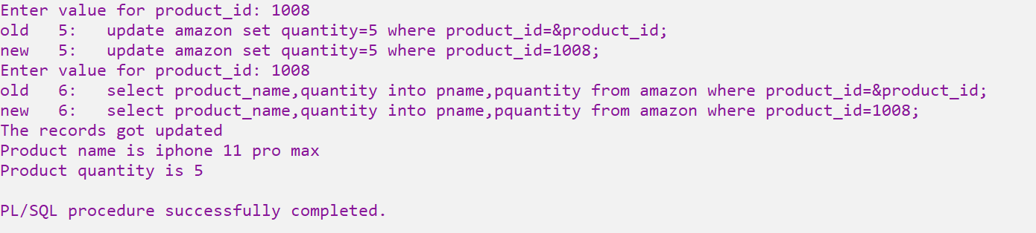

1. Write a PL/SQL block to delete a particular product record by taking its product_id interactively.

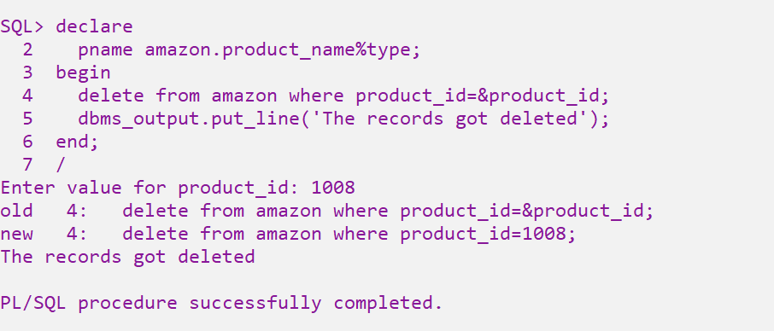

1. Write a PL/SQL block to display your regno and name

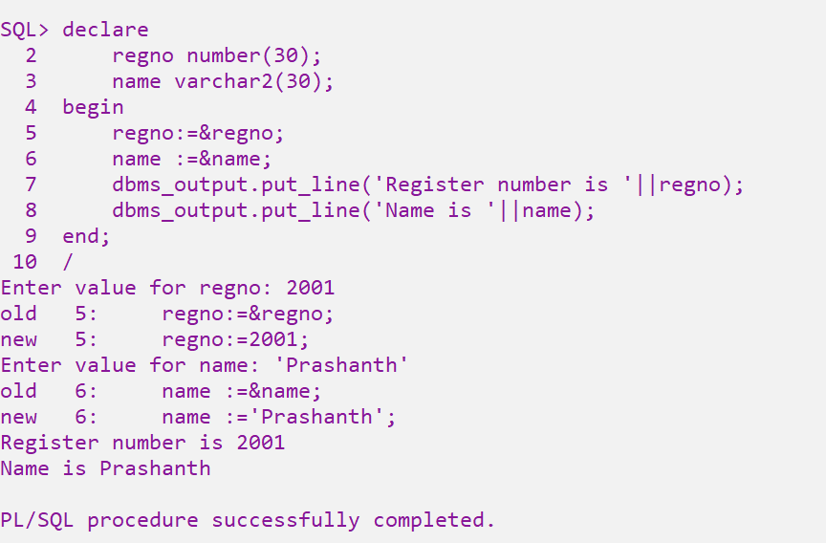

1. Write a PL/SQL block to calculate area of a circle given its radius

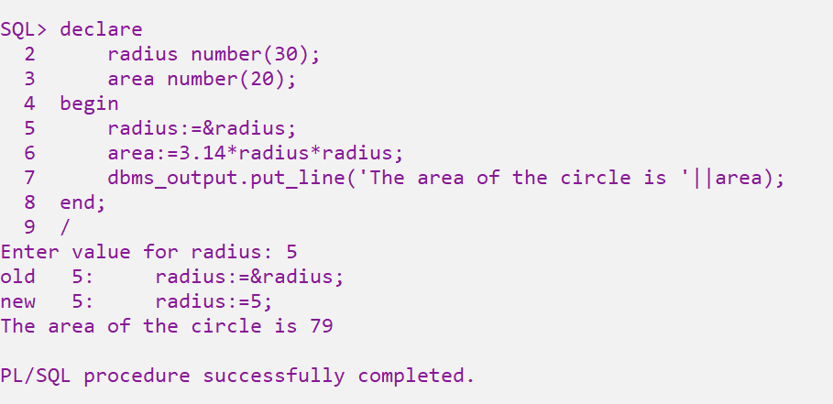

1. Write a PL/SQL block to find out Simple Interest given P=10000, N=2 and R=10% (Hint: Simple Interest(SI)=(P*N*R)/100)

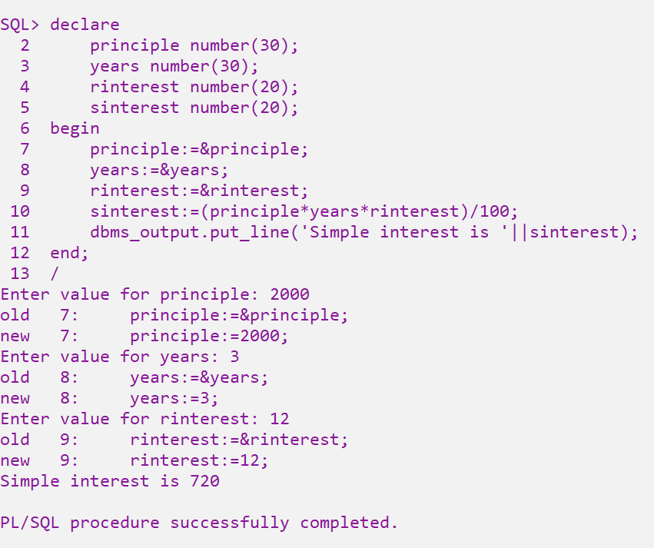

1. Write a PL/SQL block to check whether entered character is either vowel or consonant

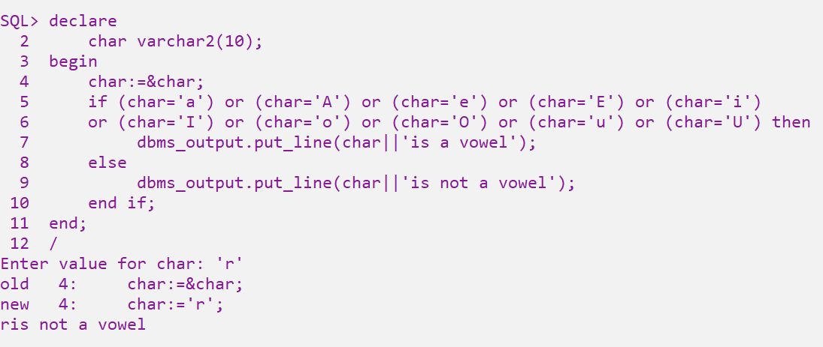

1. Write a PL/SQL block to check whether entered integer number is even or odd?

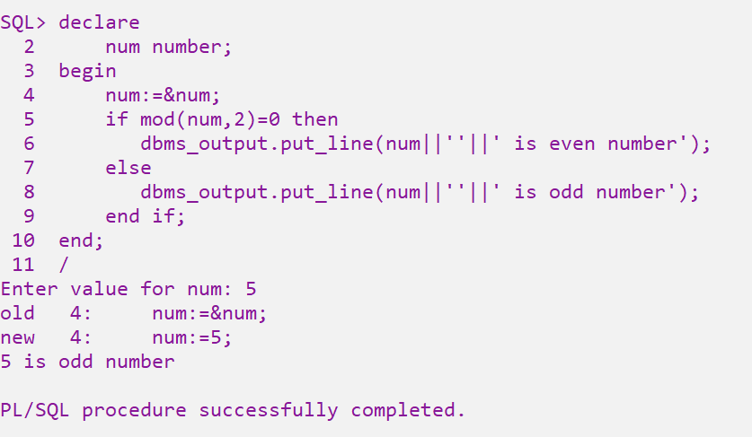

1. Write a PL/SQL program to find the smallest among three integer numbers

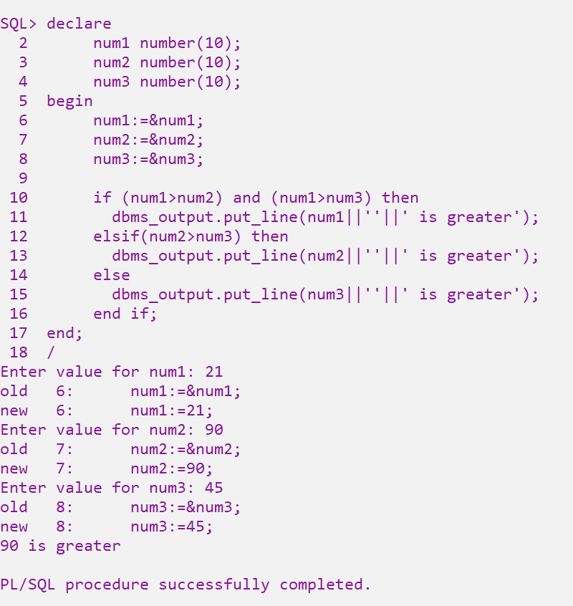

10)Write a PL/SQL program to display cadre of an employee based on his basic pay

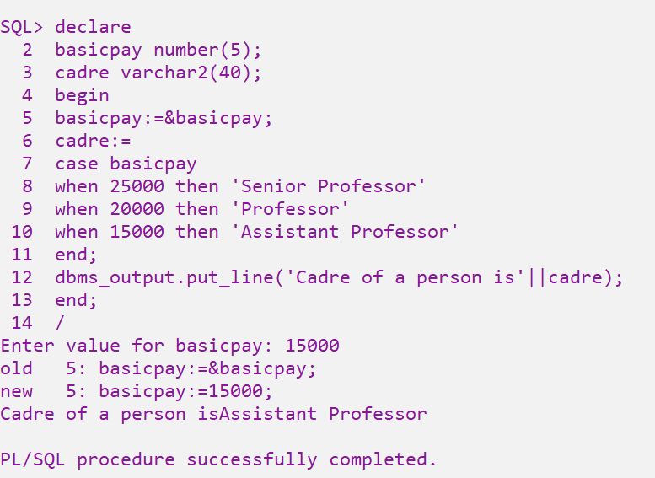

11)Write PL/SQL program to display even numbers between 1 and 40

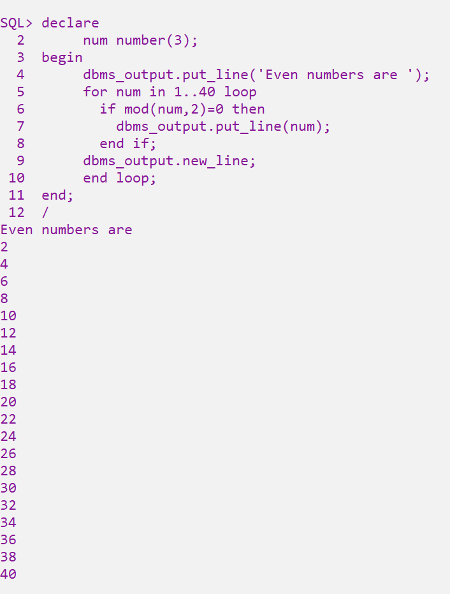

12) Write PL/SQL block to display factorial of given number

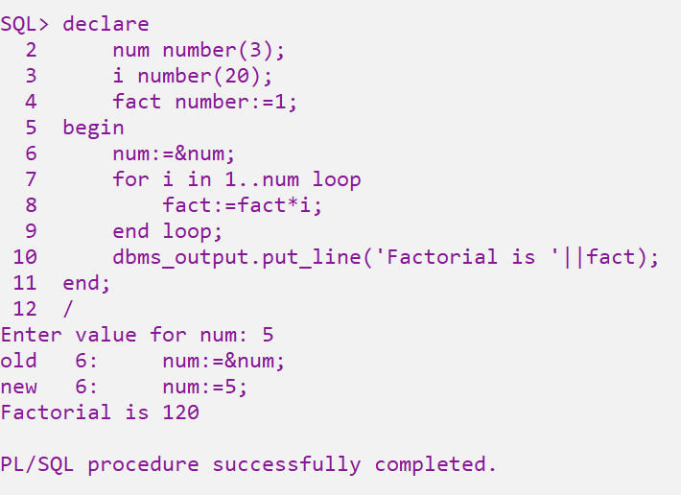

13) Write PL/SQL block to display reverse number of given number

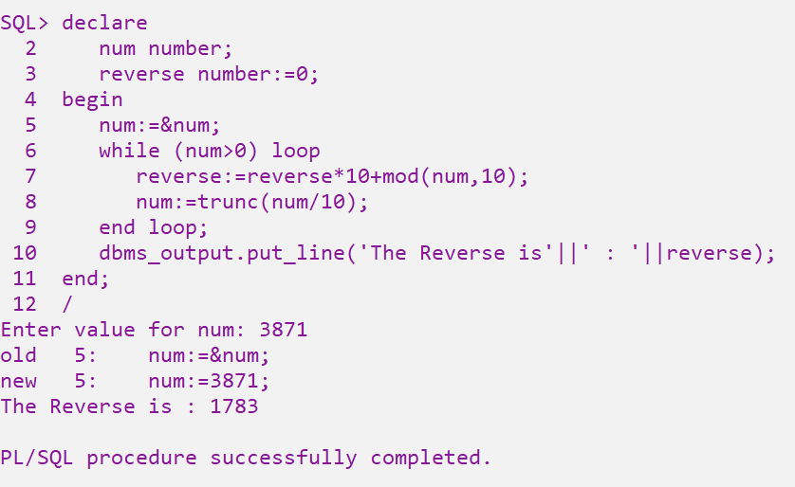

14) Write PL/SQL block to generate Fibonacci Series up to given number

